# Jupyter to Medium

[jupyter-to-medium · PyPI](https://pypi.org/project/jupyter-to-medium/)

Publish Jupyter Notebooks as Medium blog posts directly from your notebook with the help of jupyter_to_medium.

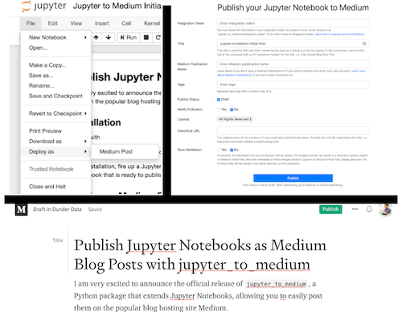

# DataCamp Cheat Sheets For Data Scientists

* [Cheat sheets for data scientists](https://www.datacamp.com/community/data-science-cheatsheets)
* [Cheat sheet de Pandas](http://datacamp-community-prod.s3.amazonaws.com/ba1fe95a-8b70-4d2f-95b0-bc954e9071b0)
* [Cheat sheet de Numpy](http://datacamp-community-prod.s3.amazonaws.com/f04456d7-8e61-482f-9cc9-da6f7f25fc9b)